**Residential Building Permits**

Source: MA State Data Center/U.S. Census Building Permit Survey

Link:1. <https://www.census.gov/construction/bps/>

2. <http://www.massbenchmarks.org/statedata/data.htm>

Ref 1: **Massachusetts Economic Due Diligence**

1. Construction sector (NAICS 23)
2. Building permits: A-Appendix-2;

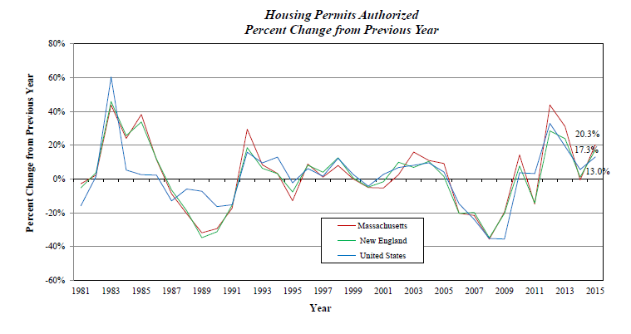

Ref 2 : **U.S. Census Building Permit Survey** (web, link 1)

Building permits data are collected from individual permit offices, most of which are municipalities. The data are aggregated each year to the county level. The statistics are based on reports submitted by local building permit officials in response to a mail survey. When a report is not received, missing data are either (1) obtained from the Survey of Use of Permits (SUP) which is used to collect information on housing starts, or (2) imputed.

**EXPLANATORY NOTES:** In interpreting changes in the statistics in this release, note that month-to-month changes in seasonally adjusted statistics often show movements which may be irregular. It may take 3 months to establish an underlying trend for building permit authorizations, 6 months for total starts, and 6 months for total completions. The statistics in this release are estimated from sample surveys and are subject to sampling variability as well as nonsampling error including bias and variance from response, nonreporting, and undercoverage. Estimated relative standard errors of the most recent data are shown in the tables. Whenever a statement such as “2.5 percent (±3.2%) above” appears in the text, this indicates the range (-0.7 to +5.7 percent) in which the actual percent change is likely to have occurred. All ranges given for percent changes are 90-percent confidence intervals and account only for sampling variability. If a range does not contain zero, the change is statistically significant. If it does contain zero, the change is not statistically significant; that is, it is uncertain whether there was an increase or decrease. The same policies apply to the confidence intervals for percent changes shown in the tables. On average, the preliminary seasonally adjusted estimates of total building permits, housing starts and housing completions are revised two percent or less. Explanations of confidence intervals and sampling variability can be found on our web site listed above.

**Plot 2:** Housing Units by Structure

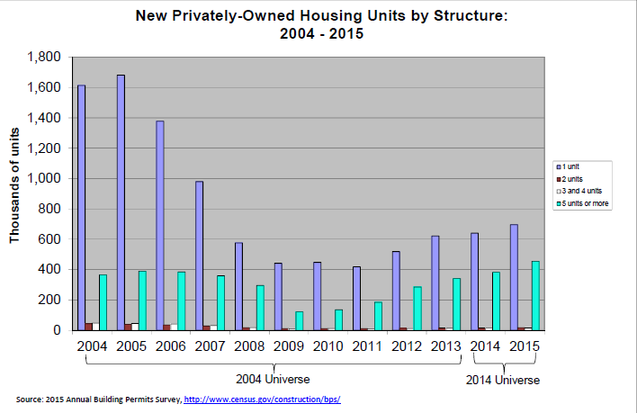

The 2014 Universe includes approximately 20,100 permit-issuing places and is used from January 2014 forward.

The 2004 Universe included approximately 19,300 permit-issuing places and was used from January 2004 to December 2014.

 Universe refers to the number of permit-issuing jurisdictions canvassed for the Building Permits Survey. The universe is updated every 10 years.

Data are obtained from the U.S. Census Bureau's Survey of Construction. Since the Survey of Construction is designed to collect data on a monthly basis, it can only be determined in what month a building was authorized or started rather than the precise day. For example, buildings started on August 1 or August 31 would be counted as starting in August. Because of this, it is assumed for this supplement that a building authorized and started in the same month was started immediately after the permit was issued. That is, we use zero number of months in the computation. Buildings started in the first month after authorization took the full month to begin; those started in the second month after authorization took 2 months; those started in the third month after authorization took 3 months, and so on. Also, since many jurisdictions allow the ground breaking (start) to occur before the final permit is issued, there may be a negative number of months from authorization to start. For instance, projects where the building started in the month prior to the final permit use -1 in the computation of the length of time.

**Map:** 1.Map by Total Units

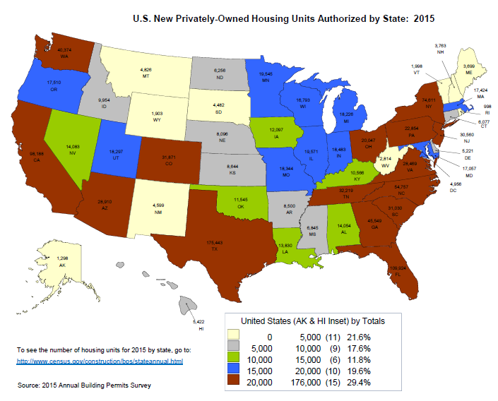

2. Map by Percentages change from 2014-2015 of New Privately-Owned Housing Units Authorized

3. Permits Per 1,000 Population